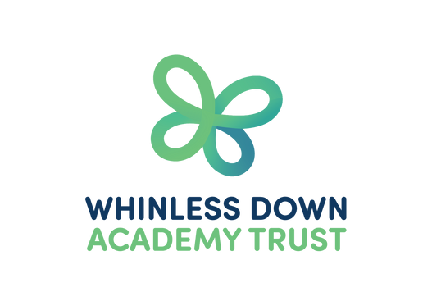
INDIGO CLASS

TERM 4 NEWSLETTER

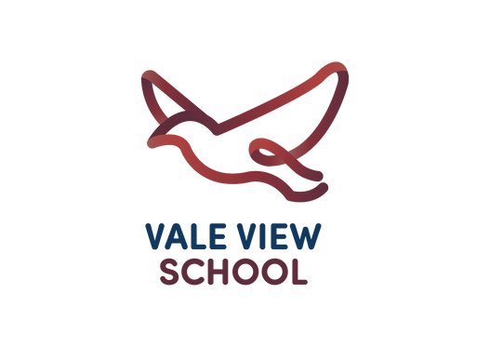
Maths

This term in Maths, we are focusing on knowing all our times tables and being able to answer them on Mathsframe within 6 seconds.
Our Maths lessons will focus on Decimals and Money.
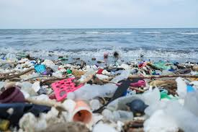
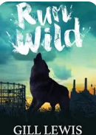

Spellings
We will focus on the ous suffix and words ending in -gue and -que
PSHE
How can our choices make a difference to others and the environment?
RE
How do festivals and worship show what
matters to a Muslim?
Art
We will be using plastic to create works
of art.

PE
Our PE lesson will be on Wednesdays this term.
Please ensure that your child’s PE kit is always in school and earrings are taken out.
English
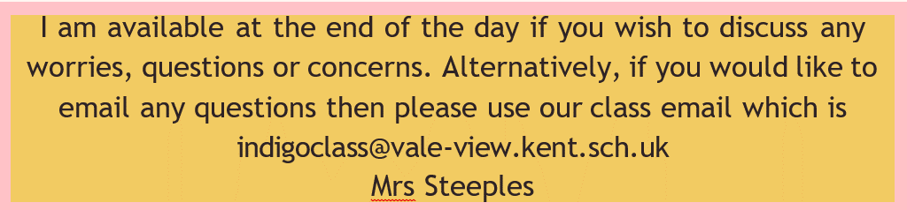
In English this term, we will be reading ‘Run Wild’ by Gill Lewis. We will be writing a setting description about it and creating haikus. Linking in with our topic we will be writing a persuasive letter, highlighting what plastic is doing to our planet and explaining ways we can help.

Geography and Science
Our topic this term is Plastic Planet' As a global citizen we have a responsibility to
respect each other’s cultures and needs and work together locally, nationally and
globally to protect our
precious planet. On our journey, we will investigate the impact humans have
on it.
I am available at the end of the day if you wish to discuss any
worries, questions or concerns. Alternatively, if you would like to email any questions then please use our class email which is indigoclass@vale-view.kent.sch.uk
Mrs Steeples

