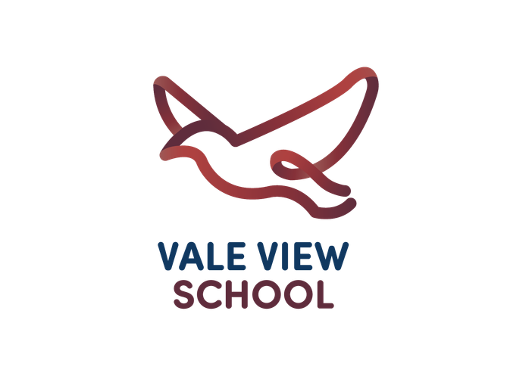
Blue Class Newsletter Term 1

English
Extreme Environments
Our topic this term is 'Extreme Environments'. In this fascinating topic the children will learn how volcanoes and mountains are formed, as well as how earthquakes come to happen. We will be exploring what rocks and fossils are and looking at how the environment has changed over time. The children will learn about the earth and how it is made and where volcanoes are around the world. We will develop our science skills by conducting investigations on rocks and soils. As amazing artists, we will develop our use of sketch books and consider how these can support us in refining our observational and sketching skills.

We will be looking at the text Stone Girl Bone Girl in order to improve our writing skills and vocabulary. We will be making links with our topic and creating our own version of the story. We will also begin our non-fiction unit by looking at recounts.

Maths

In Number Maths, we're learning all about place value; comparing , ordering, estimating, reading and writing numbers in numerals and words.

Please help your child count in 2s, 5s and 10s.
Reminders
Home learning will be set on Purple Mash every Friday and children should complete this before the following Thursday..

Children should read at least 3 times a week. Please sign in their reading record to confirm your child has read. Children have their Purple Mash and Times Table Rock Stars login in their reading records.

PE this term is on a Wednesday, children should come to school dressed in their PE kits on these days. Children need to be able to remove their own earrings for PE and must have long hair tied back.



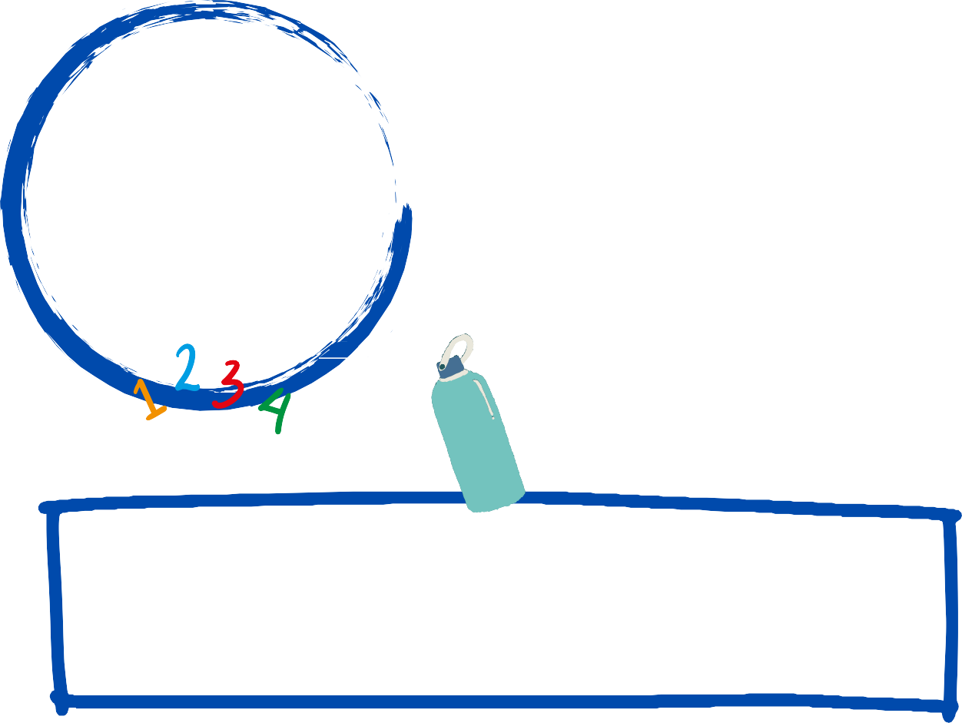



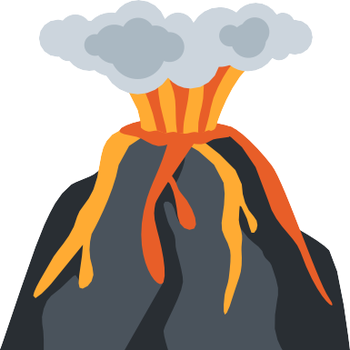
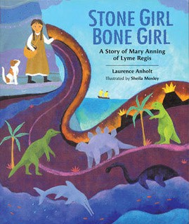


I am available at the end of the day if you wish to discuss any questions or concerns. Alternatively) please use our class email address) which is
vvyear3@vale-view.kent.sch.uk
Miss Morrison

